P234

#include<iostream>

#include<string>

using namespace std;

class student

{

public:

student(string nam, unsigned int i, double s) : name(nam), id(i), score(s){}

void input(){

cout << "name?"; cin >> name; cout << "id?"; cin >> id; cout << "score?"; cin >> score;

}

void output()

{

cout << "name:" << name << "\tid:" << id << "\tscore:" << score << endl;

};

private:

string name;

unsigned int id;

double score;

};

int main()

{

student s("\0", 0, 0);

s.input();

s.output();

}

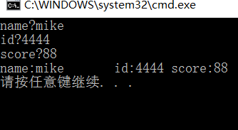

P242.1

#include<iostream>

#include<string>

using namespace std;

class Book

{

public:Book(string n, double p, int num) :bookname(n), price(p), number(num){}

void display(); void borrow(); void restore();

private:

string bookname; double price; int number;

};

void Book::borrow()

{

cout <<"已借阅，现在存书："<< number - 1;

}

void Book::restore()

{

cout << "现在存书：" << number + 1;

}

void Book::display()

{

cout << "bookname:" << bookname << " " << "price:" << price << " " << "当前存书：" << number << endl;

int n;

cout << "借书按1，还书按2,请按："; cin >> n;

if (n == 1) borrow(); if (n == 2)restore();

}

int main()

{

Book book1("22",2,4);

book1.display();

}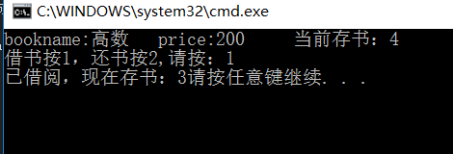

P242.3

#include<iostream>

using namespace std;

class student{

public:

void scoretotalcount(double);

static double sum();

static double average();

private:

double score;

static double total;

static int count;

};

void student::scoretotalcount(double s)

{

score = s;

count++;

total += score;

}

double student::sum()

{

return total;

}

double student::average()

{

return (total / count);

}

double student::total = 0; int student::count = 0;

int main()

{

student a;

int n, i,s; double temp;

for (i=0;;i++)

{

cout << "请输入分数:";

cin >> temp;

a.scoretotalcount(temp);

cout << "总分：" << a.sum() << endl;

cout << "平均值：" << a.average() << endl;

cout << "已输入学生数：" << i + 1 << endl;

cout << "继续输入请按1，否则按0:"; cin >> s;

if (s == 0) break;

cout << endl;

}

}